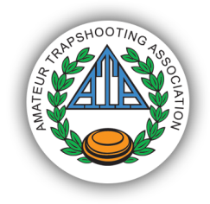Toby Bancroft Memorial 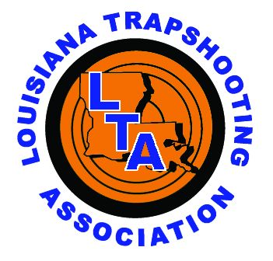
Gun Club
ATA Monthly Trap Shoot
EVENT 1 - 100 16 YARD TARGETS - SINGLES
Targets ..........................................................................................................................$28.00
ATA Daily Fees *...............................................................................................................$3.00
LTA Daily Fees *................................................................................................................$3.00
EVENT 2 - 100 HANDICAP TARGETS
Targets ...........................................................................................................................$28.00
ATA Daily Fees *................................................................................................................$3.00
LTA Daily Fees *.................................................................................................................$3.00
EVENT 3 - 50 PAIR DOUBLES TARGETS (100 TARGETS)
Targets ............................................................................................................................$28.00
ATA Daily Fees *.................................................................................................................$3.00
LTA Daily Fees *..................................................................................................................$3.00
* Daily Fees are only paid once per day.
-ATA rules apply.  -Cash and checks only.  -Shells not available.  -Shoot management reserves the right to change or modify the program in any manner deemed necessary. |  | Classification & Squadding opens at 8:15 am. Program begins as soon as a Five-man squad is ready.  Practice rounds available prior to program - $7.00 / 25 targets.  Lunch is not available. Please bring your own.

For more information contact Jim Jenkins at (318)387-9905 or jsjenkins@att.net or Donny Sanders at (318)348-0171 or sand9229@suddenlink.net

